UML LAB INTERNAL-1

A.harshitha

B2-39

1a) Which of the following statements are not enforced by the following sequence diagram?

1. m1 is received before m2 is m2 is send
2. m2 is received before m3 is send
3. m1 is send before m2 is send
4. iv) m2 is send before m3 is send

ANS- option (b)

b) Define Component diagram?

ANS- The component diagram main purpose is to show the structural relationships between the component of a system. UML component diagrams are great for identifying the architectural landscape for your system as they enable you to model the high-level software components, and more importantly the interfaces to those components.

2. Create deployment diagram for A Point-of-Sale (POS) System. A retail POS system typically includes a computer, monitor, keyboard, barcode scanners, weight scale, receipt printer, credit card processing system, etc. and POS terminal software. It interfaces to various service applications, such as a third-party tax calculator and inventory control. These systems must be relatively fault tolerant; that is, even if remote services are temporarily unavailable they must still be of capturing sales and handling at least cash payments. A POS system must support multiple and SET-9 varied client-side terminals and interfaces such as browser, PDAs, touch-screens

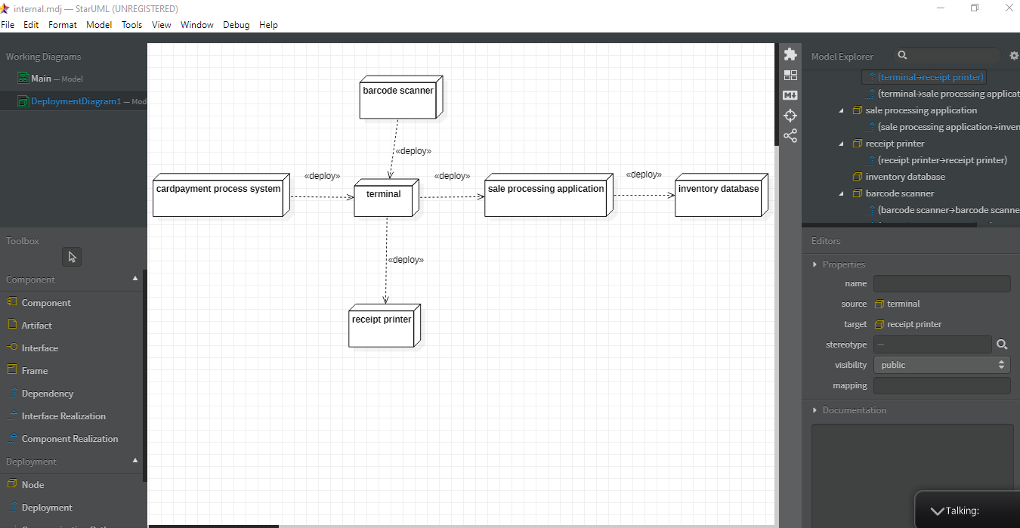

3) sequence to activity diagram: